
Feature Release Notes
KnowledgeHUB™ — Holiday Requests & Meeting Planner
A guide for staff and supervisors
August 2026

Overview
KnowledgeHUB™ now includes a full self-service Holiday Requests system and a Meeting Planner tool for supervisors. Together, these features let staff book and track their own holiday, give supervisors a single place to approve requests and monitor team absence, and take the manual work out of finding a date when several people are free at once.
This document walks through a single, real example — Mark Ninnim requesting two days off, and his supervisor Dan Maskell approving it — to show the whole loop from both sides. It then covers how the numbers are shown, the Home page holiday ticker, and finally the Meeting Planner. Screenshots throughout were captured live on KnowledgeHUB™, switching between Mark's own account and a supervisor view of Dan Maskell.
In this document
- Booking holiday — Mark requests two days off
- Approving holiday — Dan is notified and approves
- Seeing the numbers — allowance, carried-over, taken and balance
- The Home page holiday ticker — and why it shows what it shows
- The Meeting Planner — finding a date everyone is free
1. Booking Holiday — Mark Requests Time Off
Every member of staff can view and request their own holiday from the My Holiday panel, accessible via the calendar icon in the top navigation bar.
1.1 Requesting a new holiday
Mark opens My Holiday, sees his allowance summary at the top, and fills in a simple request form: start date, end date, and an optional note. Submitting the form sends the request straight to his designated approver — in this case, Dan Maskell.
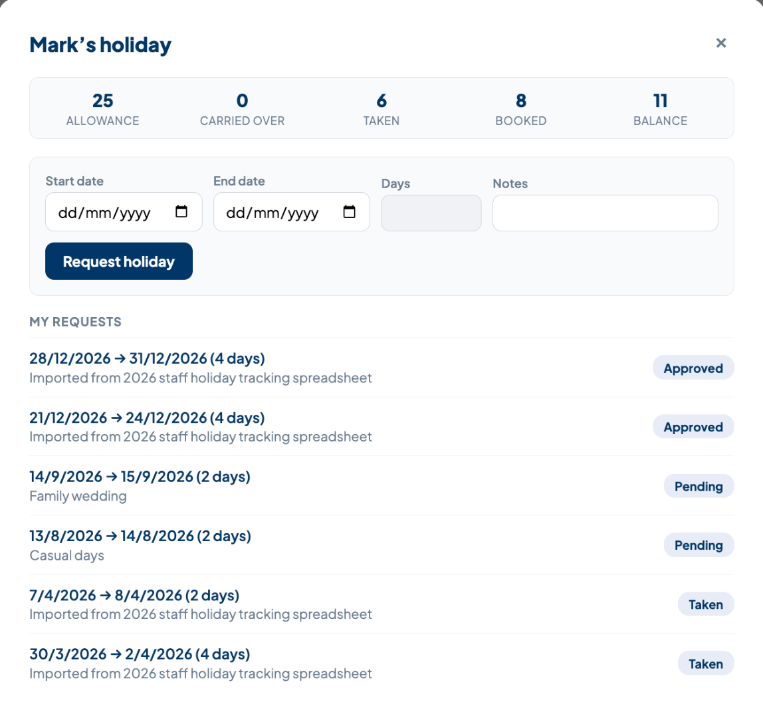
Mark's holiday: a new request for 14–15 September 2026 ("Family wedding") shows as Pending, alongside his existing request history.
The request appears immediately with a Pending status — there's no page reload or delay.
1.2 Two ways to check your own holiday
Staff can get to their own holiday balance and request history in whichever way suits them — there's no need to remember a single path.
- The My Holiday button in the top navigation bar, available from any page, opens the same panel as a pop-up.
- Scrolling down the Home page reveals a “Your Holiday” panel showing the same allowance, taken, booked and balance figures, plus the same request form, inline — no click required.

Method 1 — the My Holiday button in the top navigation bar.
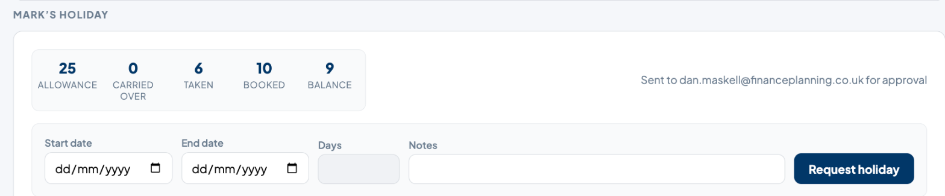
Method 2 — scrolling down the Home page to the inline holiday panel.
1.3 Who approves your holiday
Each person's holiday requests are routed to a designated approver, set against their profile in User Management, reflecting the firm's team structure:
- Dan Maskell approves holiday for the Directors.
- Pete Burgess approves holiday for the Compliance team.
- Matt Stephens approves holiday for the Sales team.
- David Riley approves holiday for the Admin team.
Because this is a per-person setting rather than a fixed rule, it's straightforward to reassign an individual to a different approver — for example when someone changes team or role — without any changes to the system itself.
2. Dan Is Notified
As soon as Mark submits his request, a red dot appears on Dan's notification bell — the same bell and dot used across KnowledgeHUB™ for anything awaiting his attention.

The notification bell, showing a red dot for one unread notification.
Clicking the bell shows exactly what's waiting for a decision, in plain English.
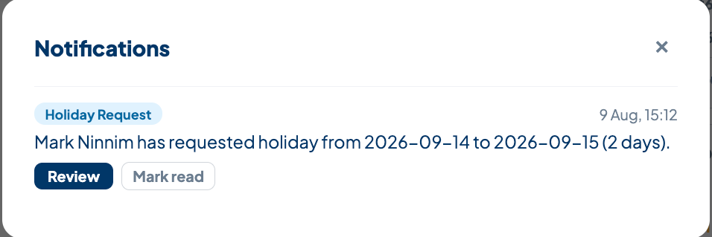
Dan's notifications: “Mark Ninnim has requested holiday from 2026-09-14 to 2026-09-15 (2 days).”
Clicking Review takes Dan straight to the Supervise → Holiday page, already filtered to Mark's name and Pending status — no need to search for the request manually.
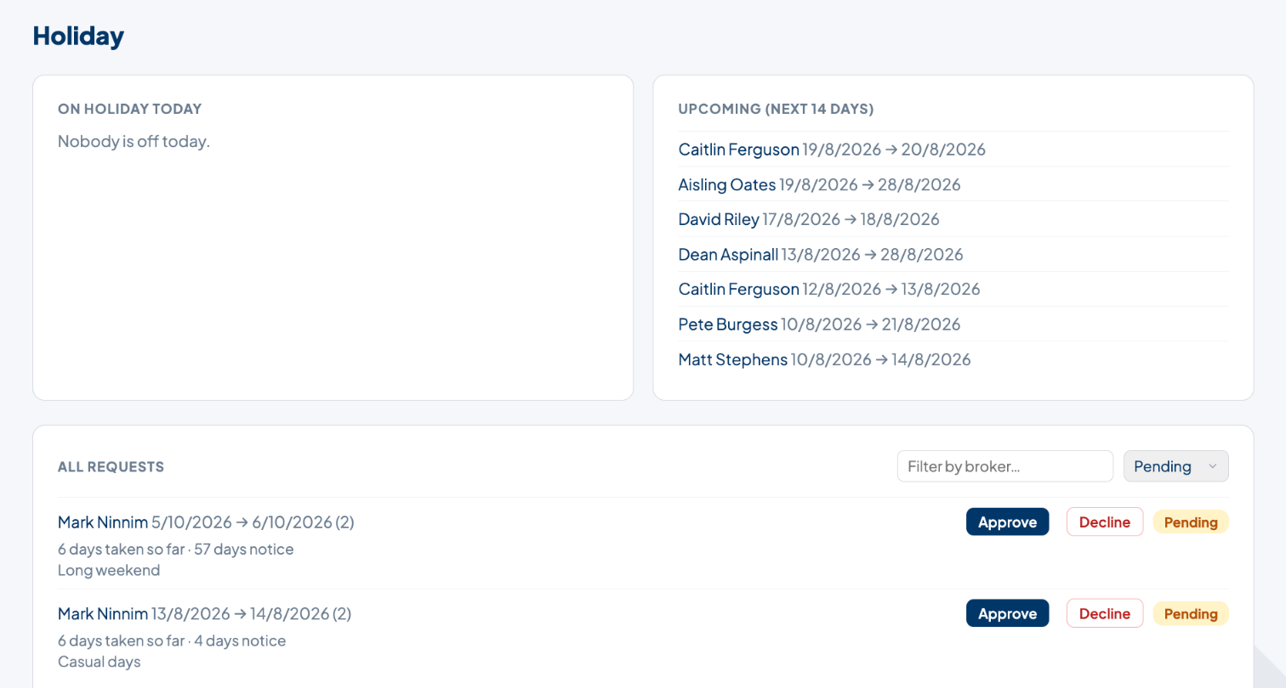
Dan lands on the filtered Holiday page: Mark's two Pending requests, each with Approve and Decline buttons on the row.
3. Dan Approves the Request
Dan reviews the dates, the notice given and the note attached, then clicks Approve directly on the row — no separate confirmation screen. The request immediately disappears from the Pending-filtered list, leaving only requests still awaiting a decision.
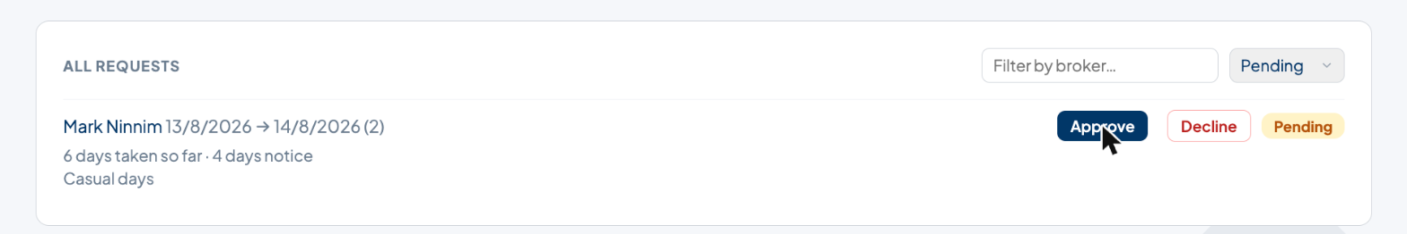
After clicking Approve, only Mark's other (still Pending) request remains in the filtered list — the "Family wedding" request has been actioned.
3.1 Mark sees the outcome
Back on Mark's own My Holiday panel, the request now shows Approved, and his Booked and Balance figures have updated automatically — with no action needed from Mark.
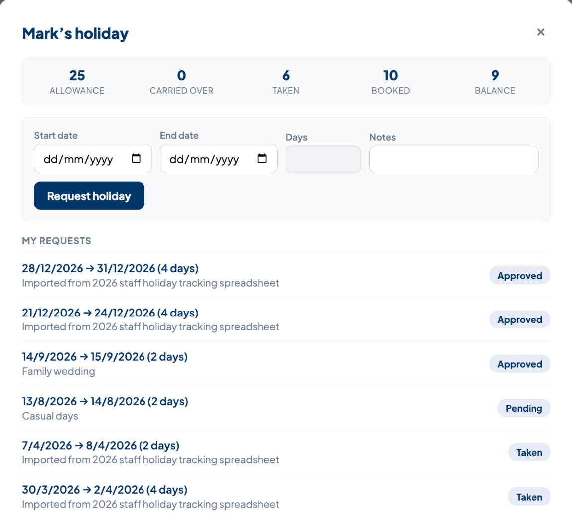
Mark's holiday: “Family wedding” is now Approved, and Booked has risen from 8 to 10 days.
Mark also gets a red dot on his own notification bell the moment Dan makes a decision, whether it's approved or declined. Previously, only the approver was notified — the person who actually asked for the time off had to remember to check back.

Mark's own bell, with a red dot for the new decision notification.
Opening it shows the outcome in plain English, colour-coded green for approved or red for declined, with a View button that takes Mark straight to his My Holiday panel.
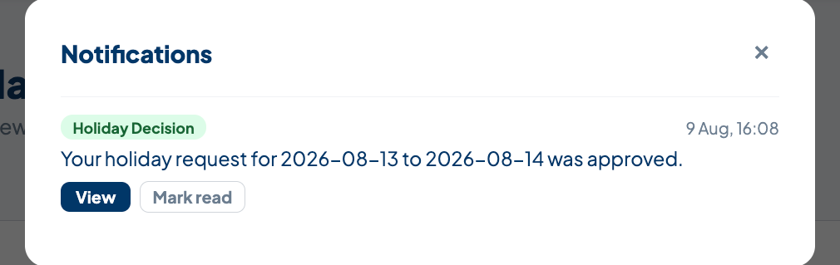
Mark's notifications: “Your holiday request for 2026-08-13 to 2026-08-14 was approved.”
4. Seeing the Numbers
Both staff and supervisors can see a clear breakdown of holiday entitlement at a glance. The same five figures are shown consistently across the My Holiday panel and the Home page ticker:
Stat | What it means
Allowance | The staff member's annual holiday entitlement in days.
Carried Over | Any unused days brought forward from the previous year (2025).
Taken | Days already used this year (approved and completed).
Booked | Days approved but still in the future.
Balance | What's left to book — allowance plus carried-over, minus taken and booked.

These figures are pulled live from Airtable, so they're always up to date the moment a request is approved.
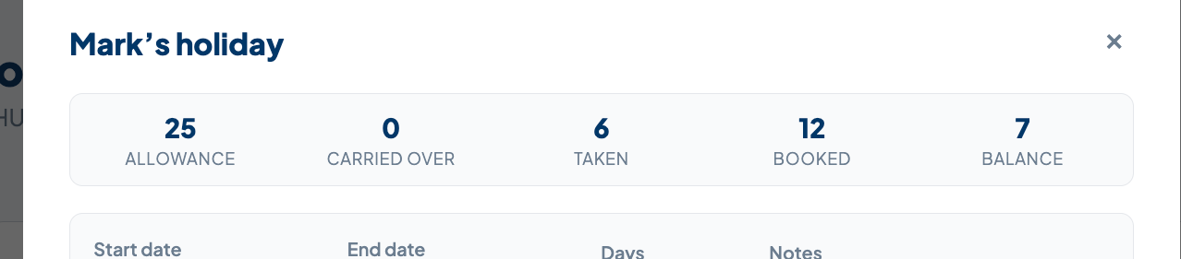
Mark's holiday: the same five figures, live on his own My Holiday panel.
The Wider Holiday Overview Page
The Holiday page under Supervise isn't just for approvals — it brings together three things at once: who's off today, who's off in the next two weeks, and every request that needs a decision. On Holiday Today lists anyone currently away, and Upcoming (Next 14 Days) gives early warning of absences coming up. The list can also be filtered by staff name (type-ahead) and by status, defaulting to Pending so a supervisor's attention goes straight to what needs a decision.
5. The Home Page Holiday Ticker — and Why It Shows What It Shows
Approvers (Dan Maskell, and the other designated approvers) see a scrolling ticker at the top of their Home page, just below the greeting. It combines two things into one line: anyone currently on holiday, and anyone starting holiday within the next 14 days — so an approver can see team absence at a glance without opening the Supervise tab at all.
Dan's Home page: the ticker scrolls through everyone currently away and everyone due off within the next 14 days.
5.1 Why Dan sees it and Mark doesn't
This ticker is deliberately limited to the people who actually approve holiday — plus administrators — rather than shown to every member of staff. Mark, as a regular staff member, doesn't see it on his own Home page; he only needs to know his own balance, which is already covered by his My Holiday panel. Dan needs the wider picture, because he's the one who has to plan around who's away.
5.2 Why it only shows the next 14 days
The ticker only looks 14 days ahead by design — far enough to plan the working week without cluttering the bar with everyone's holiday for the rest of the year. Anything further out is still visible in full on the Supervise → Holiday page's Upcoming and All Requests panels.
6. The Meeting Planner
The Meeting Planner takes the manual work out of finding a date when several people are free. Rather than checking each attendee's calendar and holiday individually, a supervisor picks a starting date and a list of attendees, and the tool proposes the earliest date everyone is available, plus five further alternatives.
6.1 Running a search
From the Meeting Planner, choose a Search From date and tick the attendees who need to be in the meeting. Clicking Search checks each attendee's booked holiday against the calendar and returns the earliest free weekday, along with five “also available” alternatives further ahead.
6.2 Understanding the result — the “why” explanation
Every result includes a short, plain-English explanation of why that date was chosen — for example, confirming how many attendees were checked and that it's the earliest date they're all free together. This replaces a verbose day-by-day breakdown with a single, clear sentence.
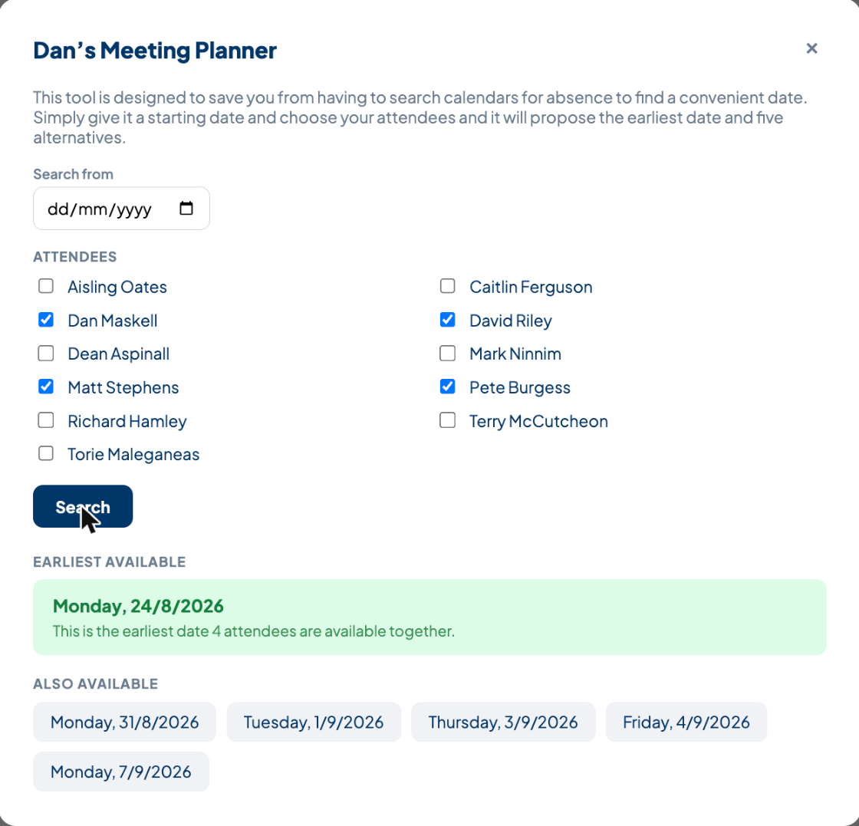
Meeting Planner: four attendees selected, earliest available date with its explanation, plus five alternatives.
In the example above, Dan Maskell, David Riley, Matt Stephens and Pete Burgess were selected. The earliest date all four are free is Monday, 24 August 2026 — the explanation confirms this is based on all 4 attendees checked, not a stale or partial count. Five further available dates are listed underneath as fallback options.
6.3 Who can use it
The Meeting Planner is restricted to supervisors and administrators, reflecting its purpose as a scheduling tool for organising team or management meetings.
Summary
The Holiday Requests system gives staff a simple, self-service way to book time off and track their allowance, while giving supervisors a single, filterable view to approve requests and stay ahead of team absence. The Meeting Planner builds on the same holiday data to remove the guesswork from scheduling meetings across multiple attendees.
Questions about either feature can be directed to the KnowledgeHUB™ team.

